Attribute | Rules | Errors | Total Errors
Outlook | Sunny → No  Overcast → Yes  Rainy → Yes | 2 out of 5  Zero  2 out of 5 | 4 out of 14
Temperature | Hot → No  Mild → Yes  Cool → Yes | 2 out of 4  2 out of 6  1 out of 4 | 5 out of 14
Humidity | High → No  Normal → Yes | 3 out of 7  1 out of 7 | 4 out of 14
Windy | False → Yes  True → No | 2 out of 8  3 out of 6 | 5 out of 14

If outlook = overcast then play = yes
If temperature = mild and windy = false then play = yes
If humidity = normal and windy = false then play = yes
If outlook = rainy and windy = false then play = yes
If outlook = sunny and humidity = high then play = no
If outlook = rainy and windy = true then play = no
Problem 2:

Full Data Set:
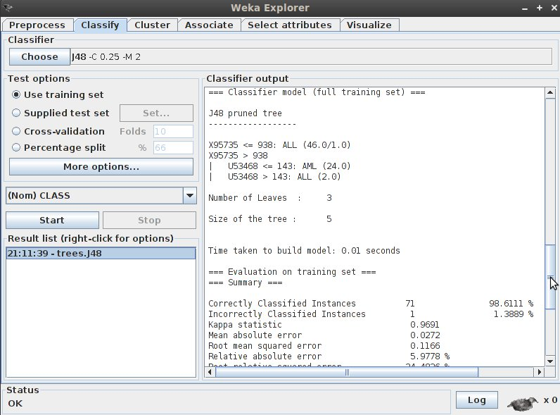
I could not, for the life of me, get the file to split properly. I tried everything I could think of and looked up all kinds of commands but none of them worked properly. I always wound up with either empty or corrupted data sets. Sadly I did not get to this assignment until the 6th, otherwise I would have sent you an email.

